From: Piruz Alemi & Zhongping Yang

To: Team #2

Subject: The Architecture of a Full Stack Application- Project #2

Date: March 9th, 2020

Greetings to All. The architecture of Full Stack Application grew out of our discussion with Json_TA, Illya, Ju Chen Issac Mollinedo & Lori Harris and their guidance, resolving some intractable errors for us. We owe them a debt of gratitude. Thank you for making our project a success in record time of 7 days in the middle of a pandemic crisis and shutdowns.

1. Briefly the full architecture consisted of a front end (Leaflet) + a Backend {SQL/MONGO DB} + Flask, as was first noted by Illya:

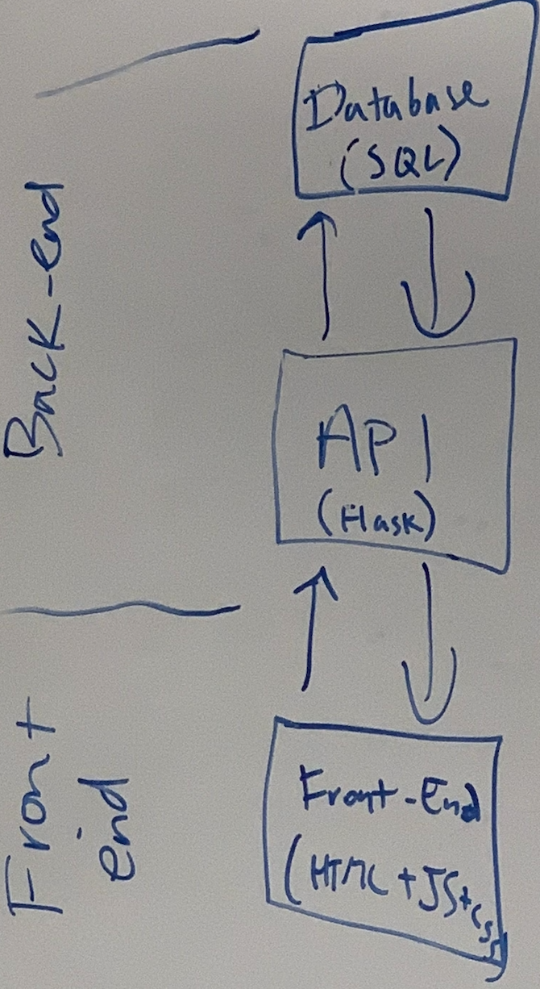

1. What we needed was to use Flask as an in intermediary step between SQL/MongoDB of our presidential elections, to safeguard our data or use a micro framework like Flask to cut the overhead, instead of accessing the full database directly.

Following code from presidents.js in line 247 connects to Flask url.

In the first place, to run presidents.js we had to activate

**python -m http.server**

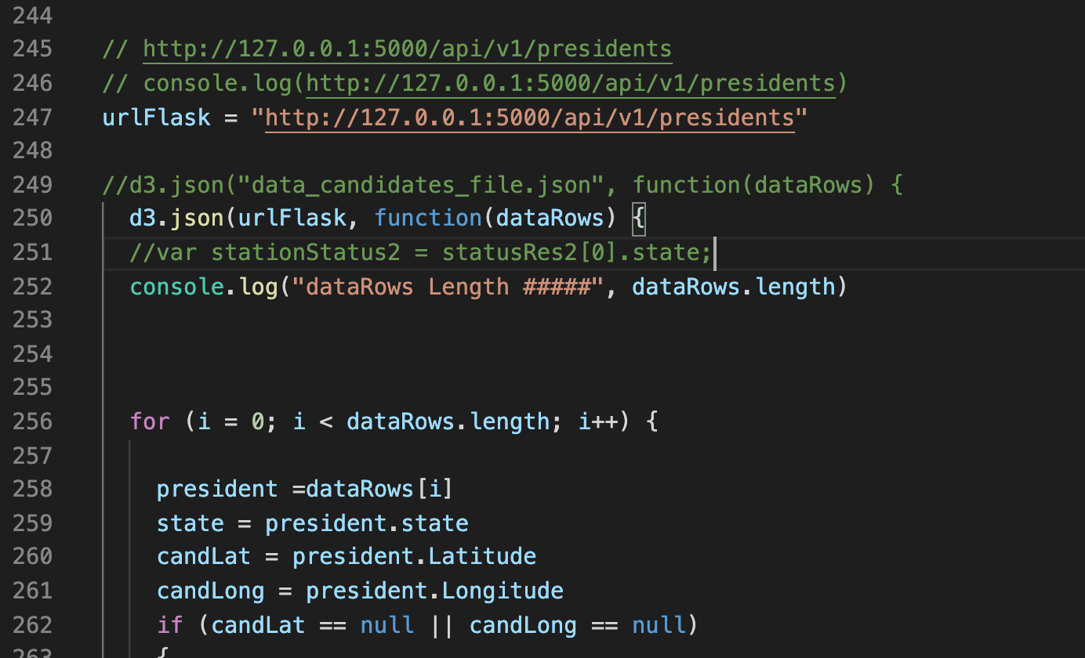

The above command would open <http://0.0.0.0:8000/index.html>

The 8000 port, whereby we could activate the index.html that would run president.js

or one of its javascripts bkups.

**FLASK:**

However to run index.html that runs presidents.js we still needed to have made the

flask active beforehand. To activate the Flask component, we did the following:

* 1. Opened a new terminal window
  2. CD to where the Flask program (api.py) resided

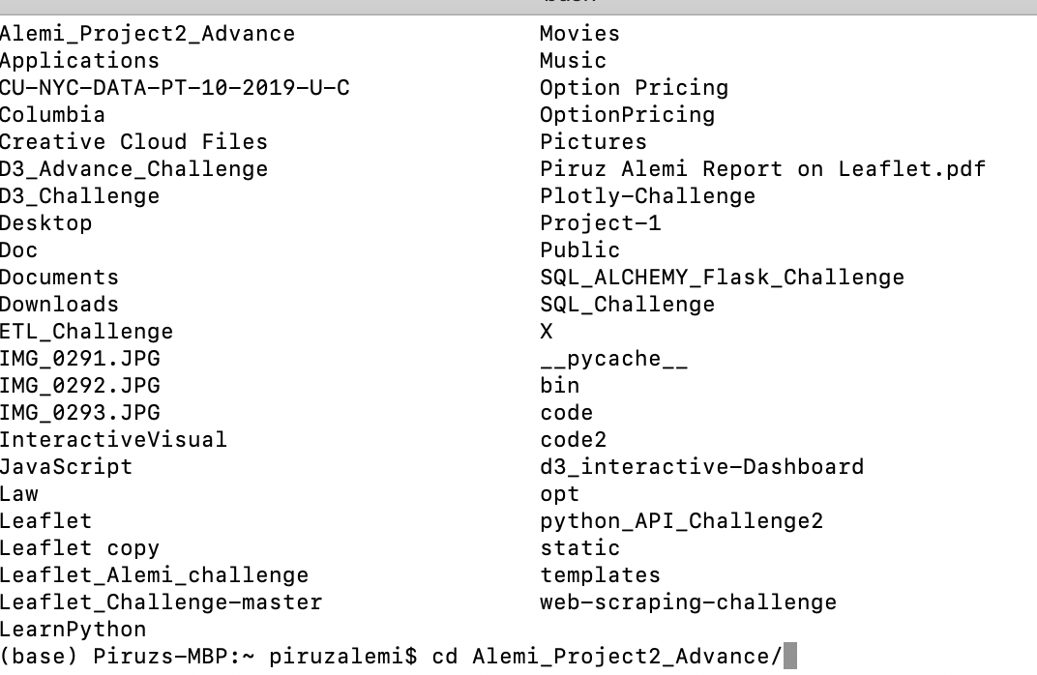

* 1. Run python api.py

This was the Flask component that would access the MongoDB and could filter any data we needed, as in collection.find{}

The terminal command would verify api.py is syntax error free and create a path between api.py Routes to MongoDB.

Program was short and brief, that after some tweeking on MongoDB collections and Return displays, it worked!

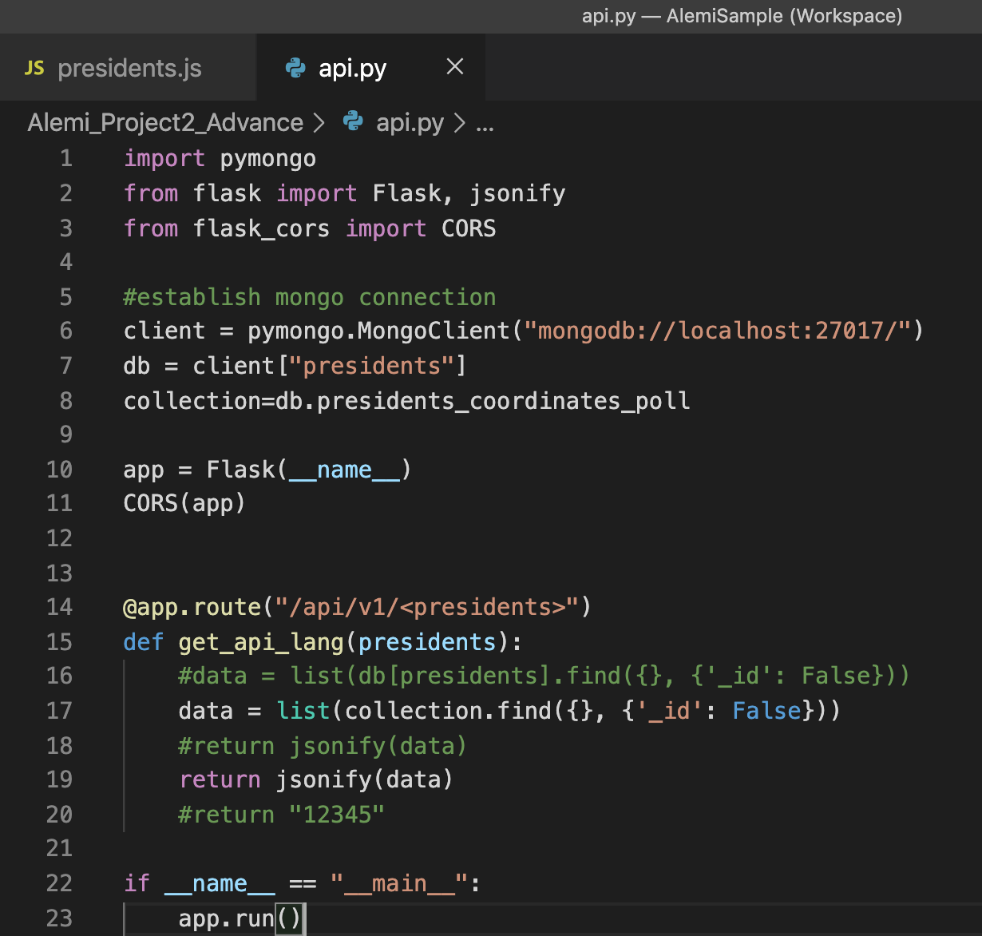

The Flask output was then tested, with and without filterings and displayed as in:

<http://127.0.0.1:5000/api/v1/presidents>

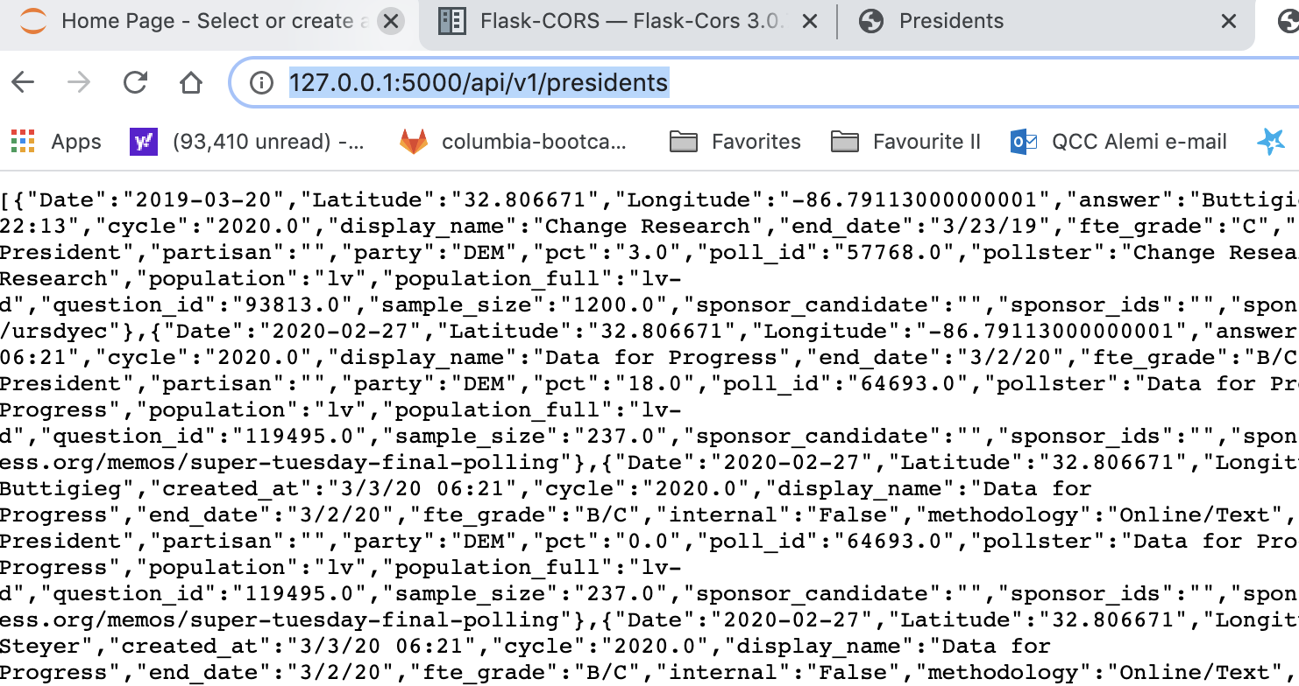

1. These breakdowns also helped in division of labor, minimizing down-time and “localizing” the errors and working in teams and identifying source of errors.

**On Some Proto-Types used and Data Cleaning:**

1. If you go to Git-Lab/ClassWork 17/logic.Js we have a good protocal of a program that reads from a url (line #2) (see below) which creates a jsonified file.
2. Once the file is jsonified, via d3.json(url), we can access the the key-_value pairs and extract the needed data as input to Leaflet/front-end program, which in our case was called earthquake.js or the presidential candidates as in presidents.js
3. Presidents-Coordinates_polling data that was created by AlemiMerge2.js program
4. We filtered this data, in 3 ways:
   1. We set some filters in the api.py under Flask as in say a selection of a candidate(S)
5. def get_api_lang(presidents):
6. #data = list(db[presidents].find({}, {'_id': False}))
7. #data = list(collection.find({}, {'_id': False}))
8. data = list(collection.find({"answer": "Sanders"}, {'_id': False}))
9. #return jsonify(data)
10. return jsonify(data)

From MongoDb, the collections was accessed, and in its document we filtered on say “Sanders”

Filtering in api.py under Flask

Filtering in MongoDB

Filtering in Predident.js as in suppression of Null values of long and lat in coordinates.

1. Recall, The Alemimerge2.js program that read a CSV file of presidential polling data and left joined it with State-GPS Coordinates files, based on State Codes. In addition it created an SQL data base.
2. We also imported the CSV file into MONGODB. In this case we created presidents DB and added presidents_coordinates_poll.csv file to its collection with 18,296 documents, as shown:

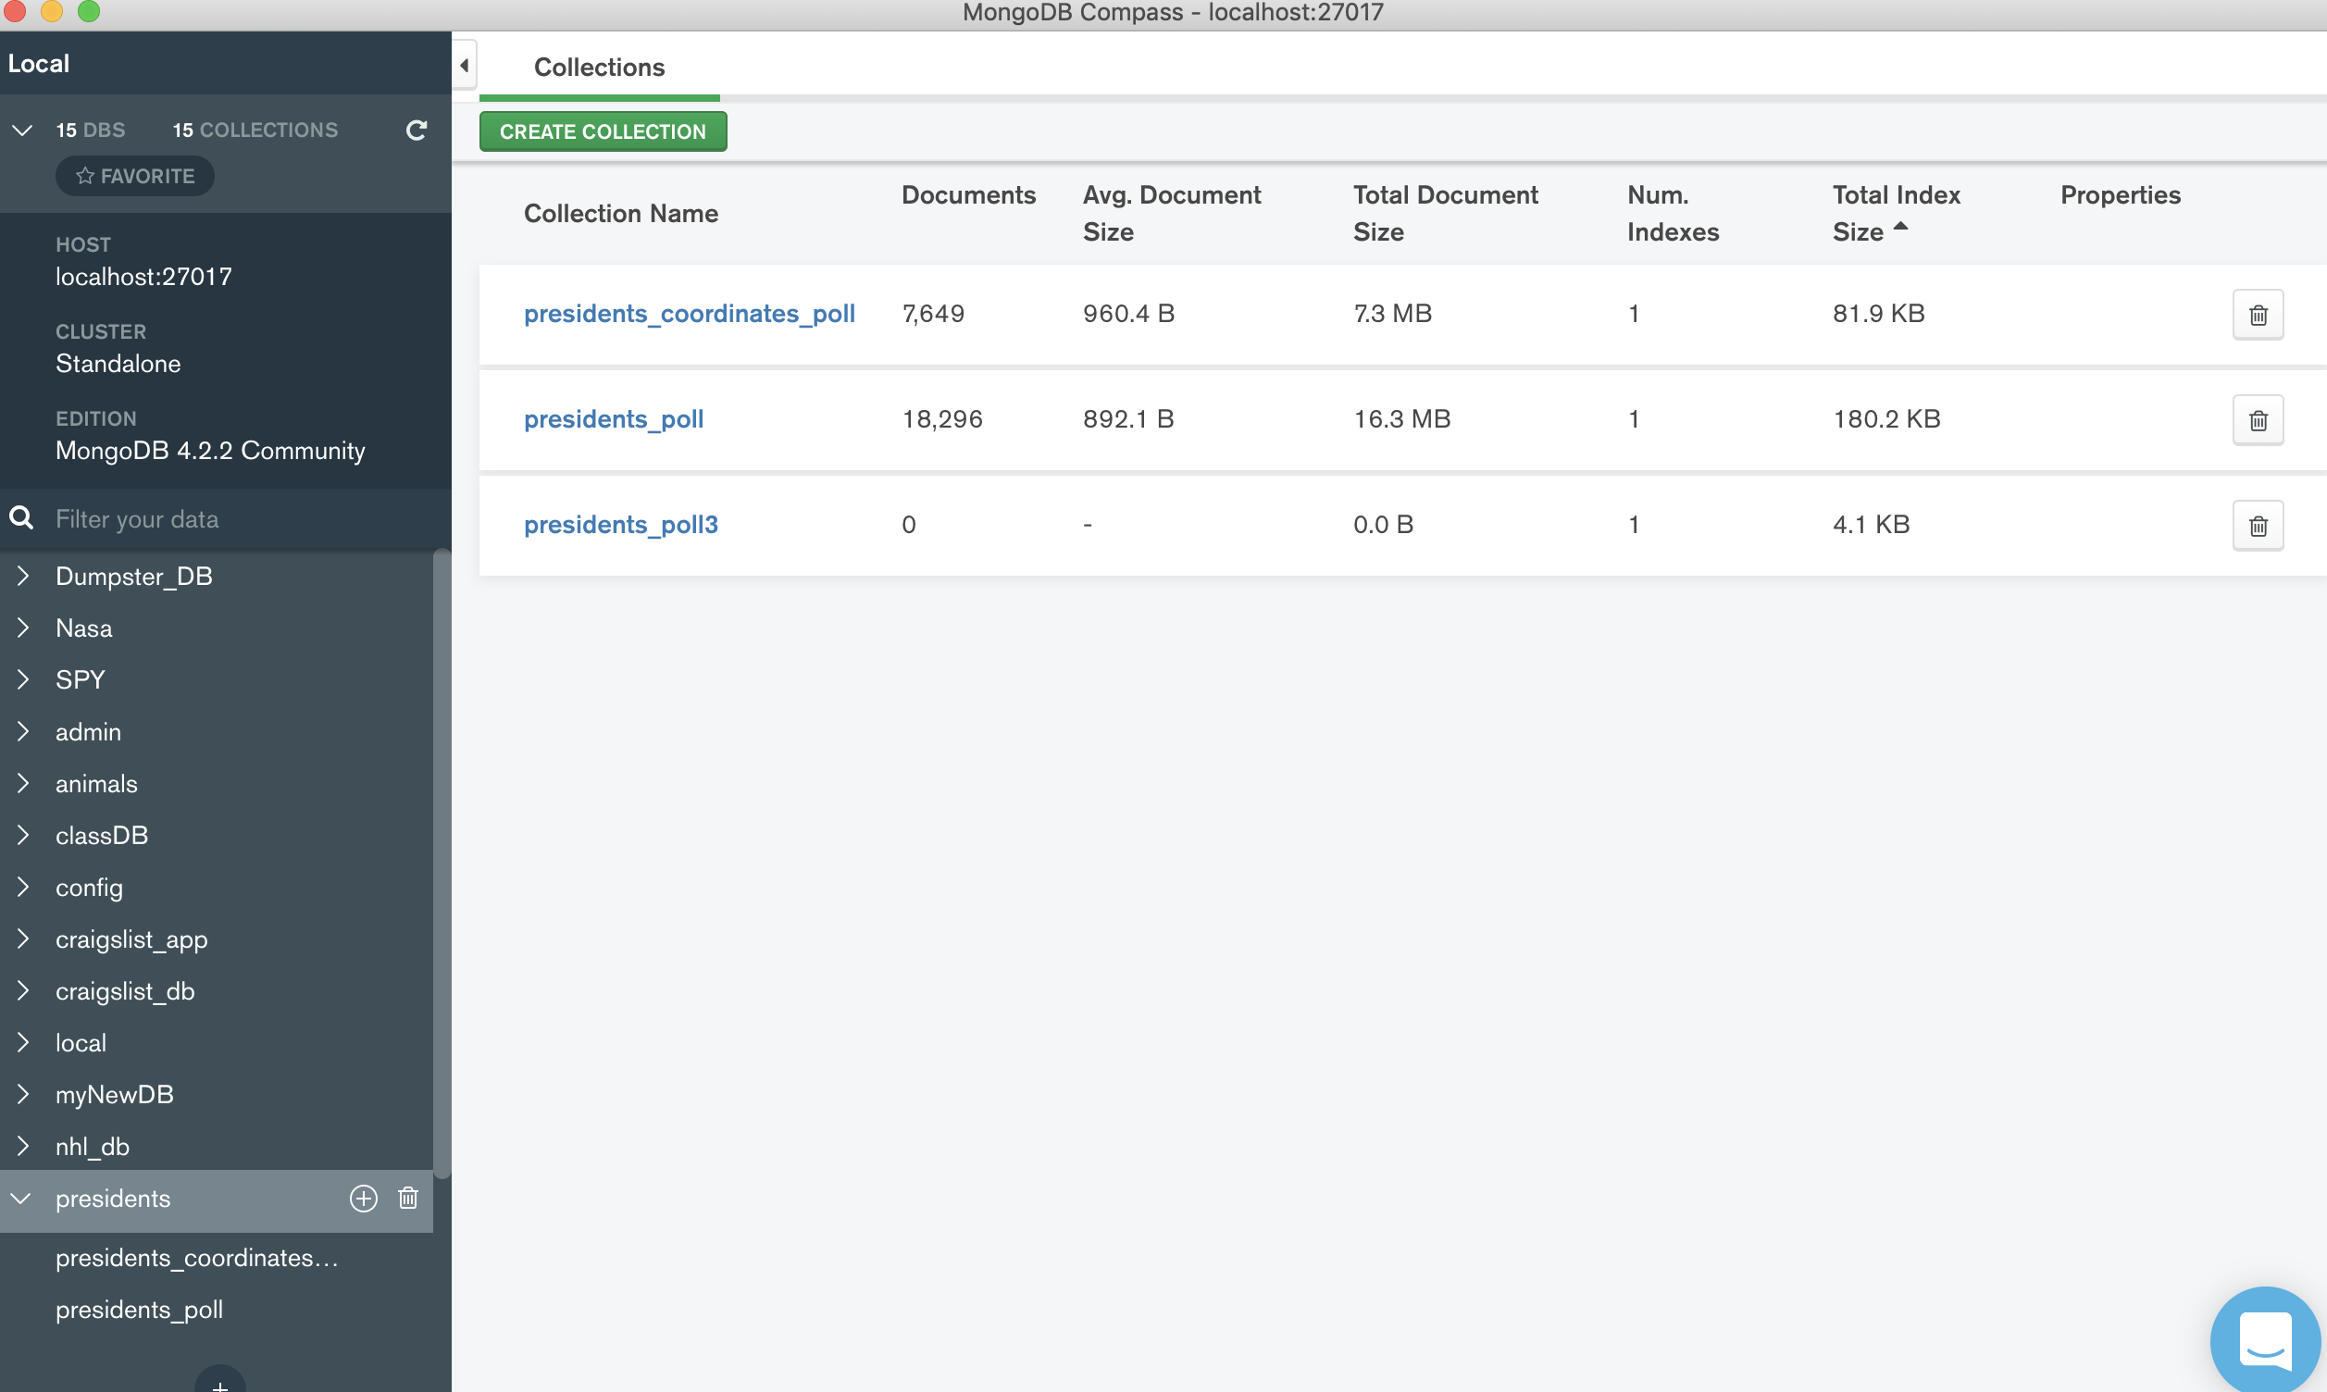

The data now included the coordinates of the State, where we could tell Leaflet to add the marker vectors on its map layers.

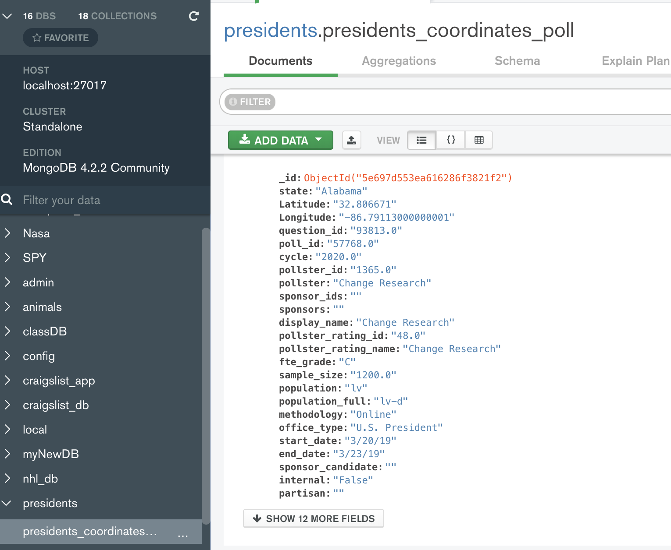

_________________________________________________________________

In our case line 2 becomes the Flask URL that was accessing/interfacing with DB: SQL/MONGODB. Some of the data in fields of interest lik Longitude & Latitude had nulls that we excluded.

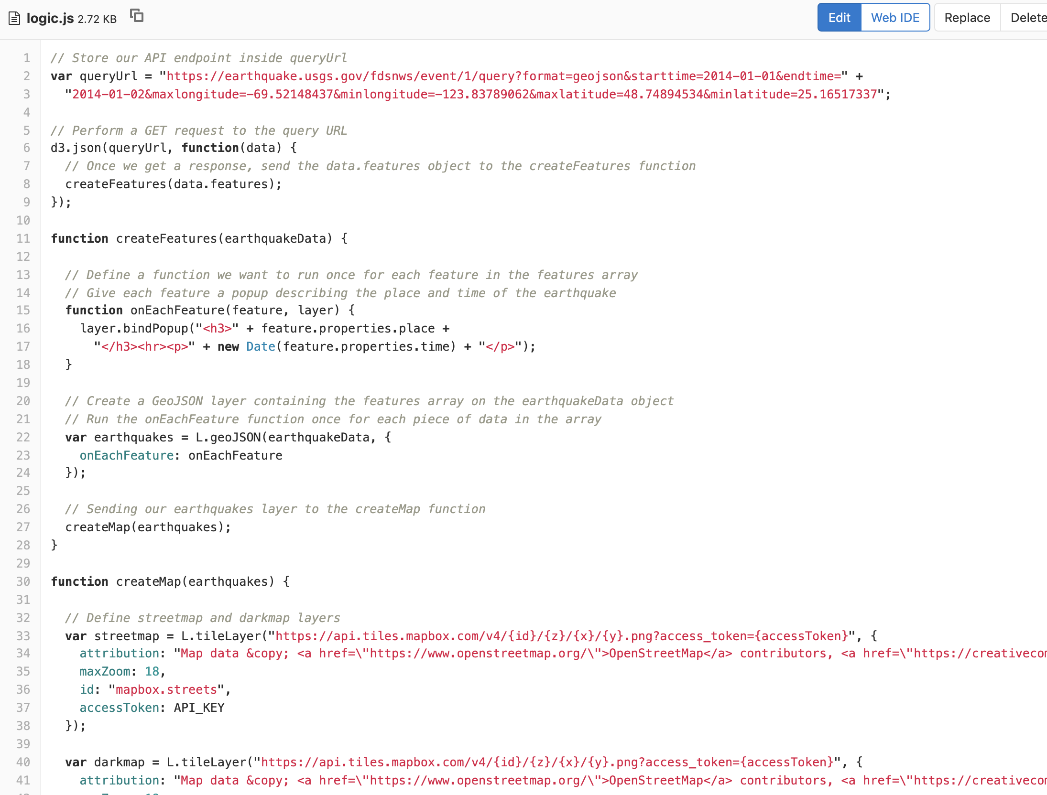

**Flask_CORS**

Note worthy was the use of CORS that resolved the conflicts between two separate session URLS

We had to install Flask CORS <https://flask-cors.readthedocs.io/en/latest/index.html>

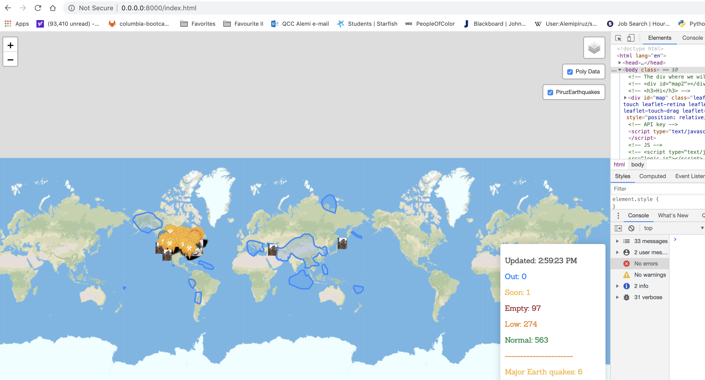

But we could also run without CORS, as in the change of the architecture, where First Flask is run. Running flask via render template required some quick restructuring as in:

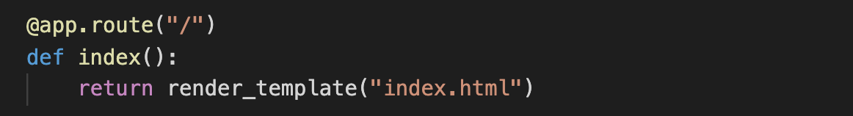

Helpful Links:

* <https://docs.mongodb.com/manual/reference/method/db.collection.find/>
* <https://getbootstrap.com/docs/4.3/getting-started/introduction/>
* <https://stackoverflow.com/questions/33962616/setting-full-screen-leaflet-js-map-using-bootstrap>
* <https://getbootstrap.com/docs/4.3/getting-started/introduction/>
* <https://embed.plnkr.co/plunk/VyCze8>
* <https://icons8.com/icon/pack/cultures/doodle>
* <https://i.vimeocdn.com/portrait/3134773_600x600.webp>

**Results:**

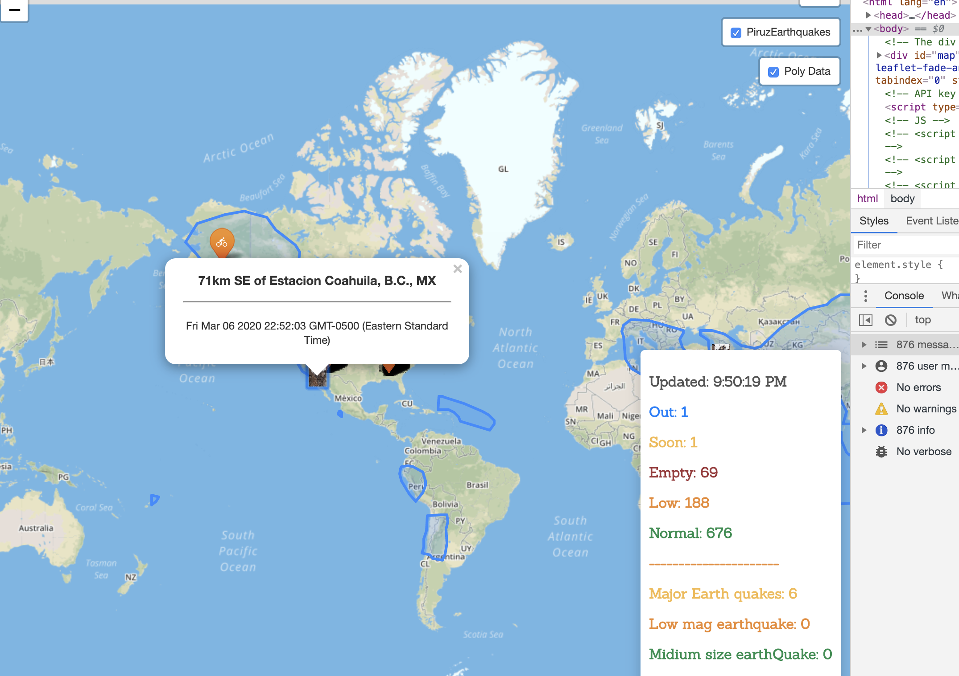

Captures the earthquakes location, date and time + its Poly data

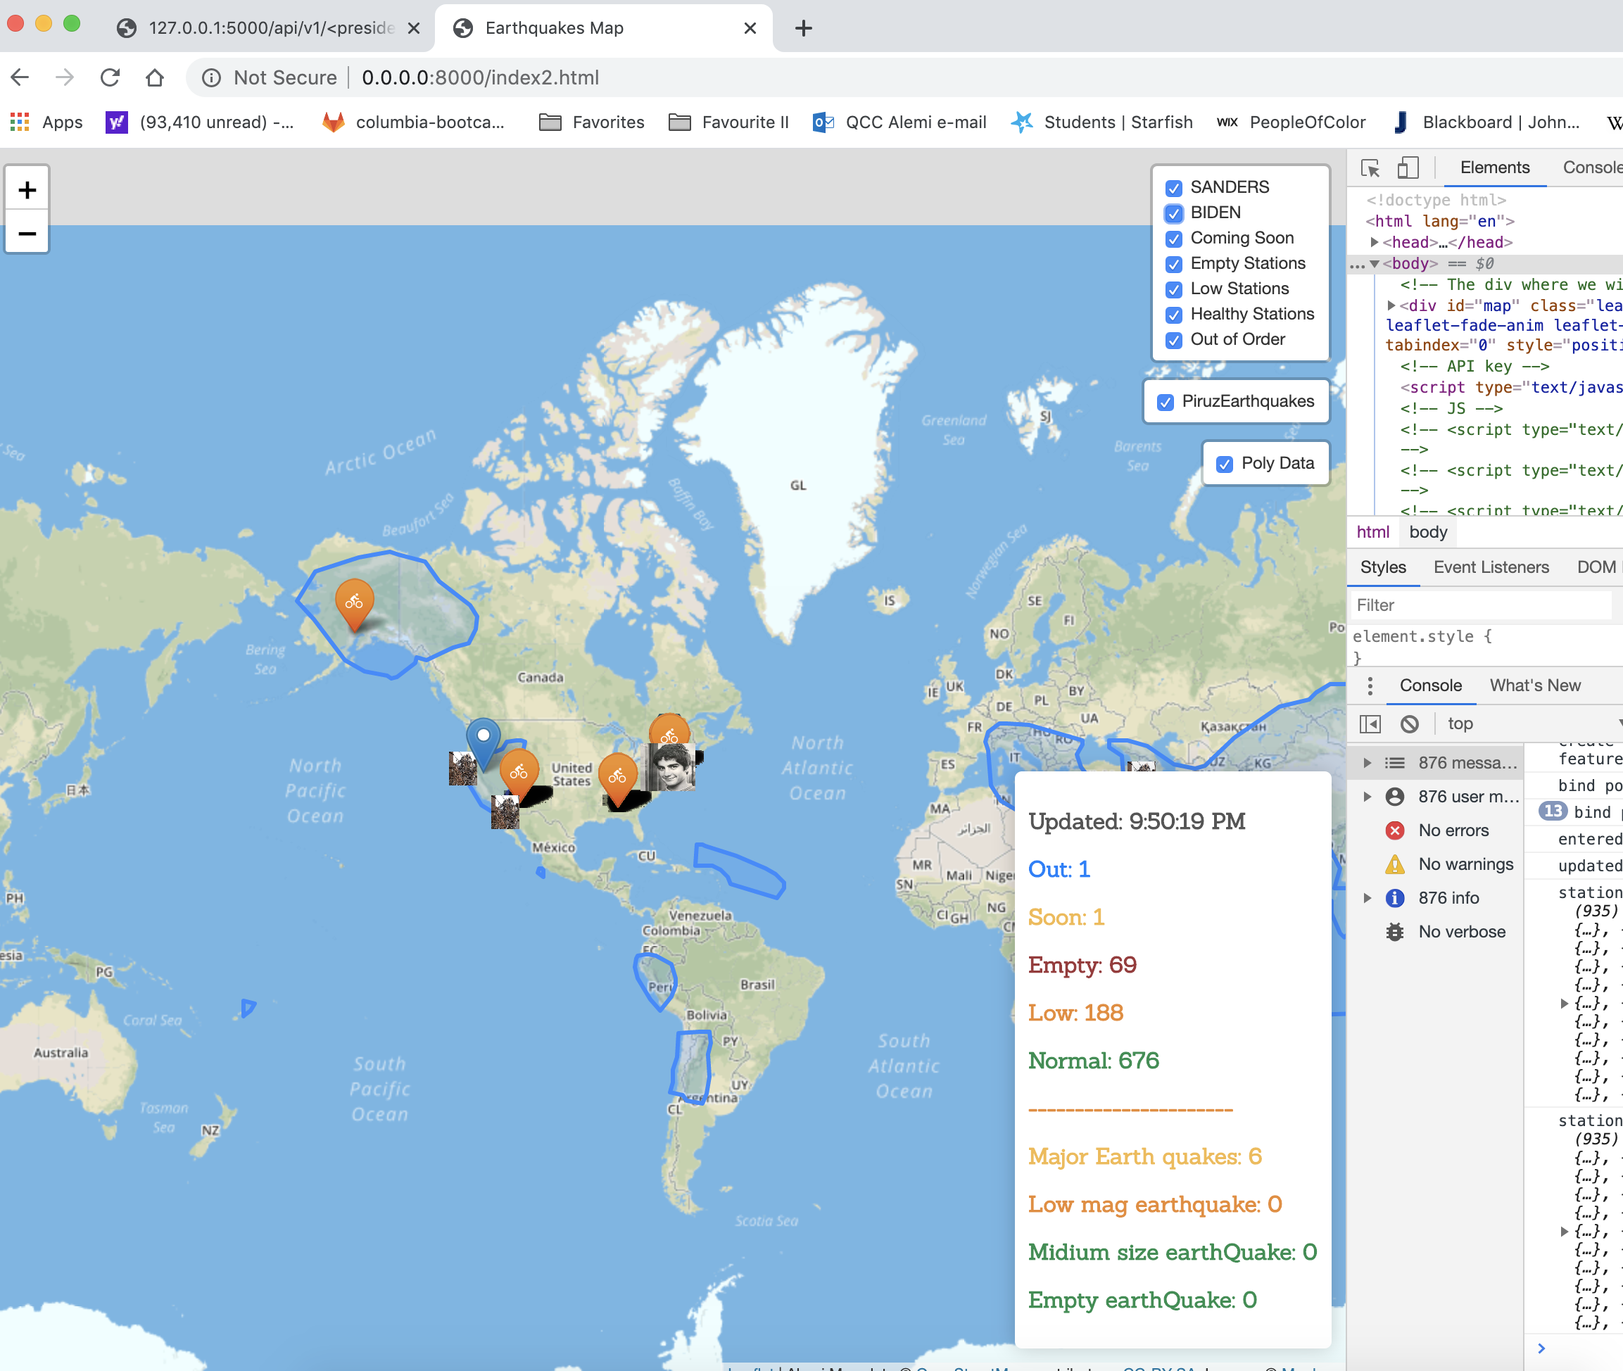

It also captures the Votes distribution:

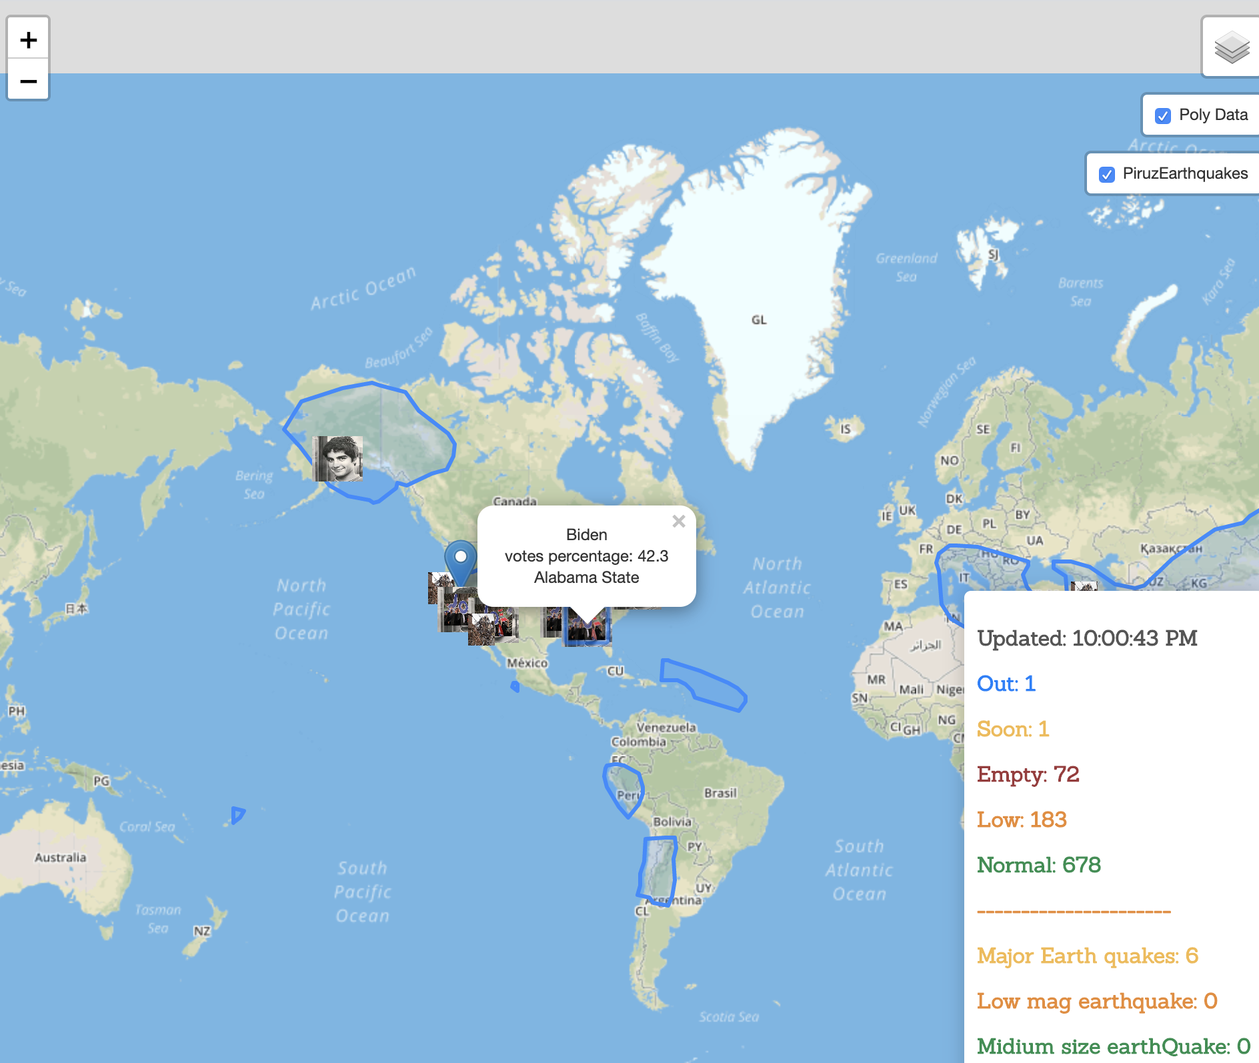

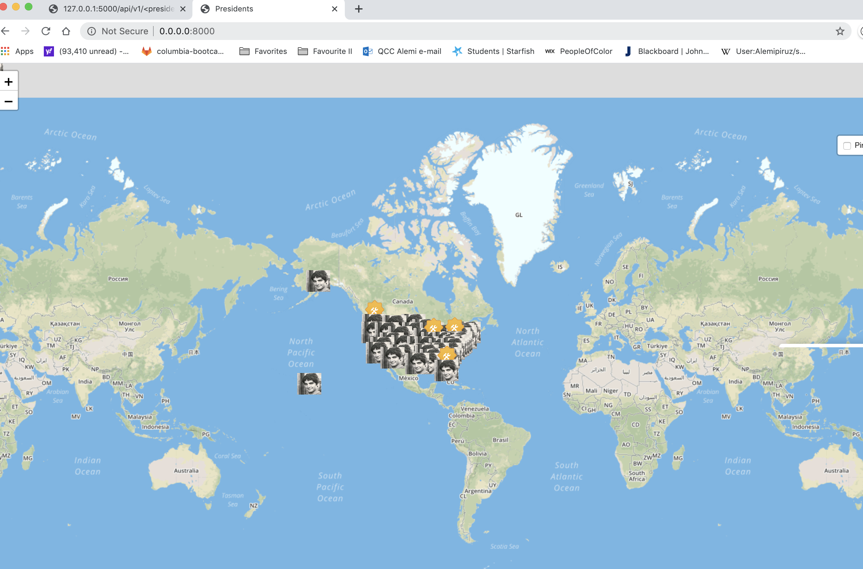

Selecting on Biden only:

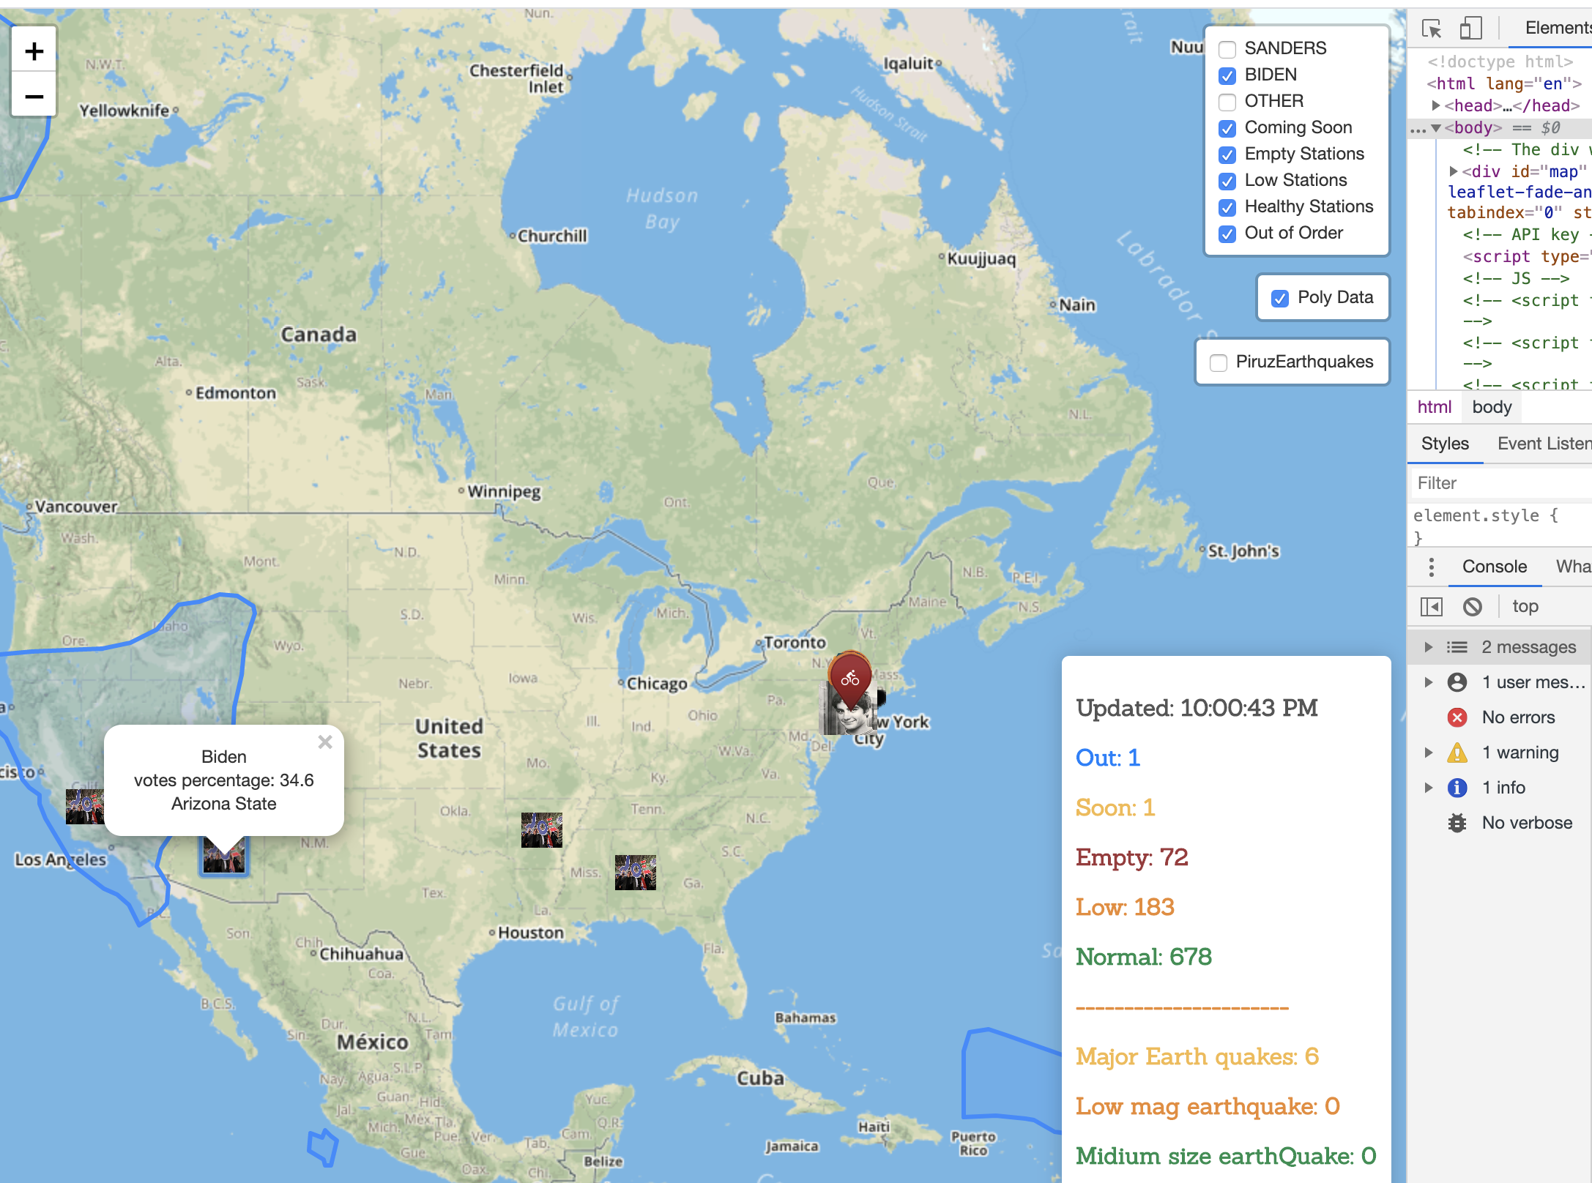

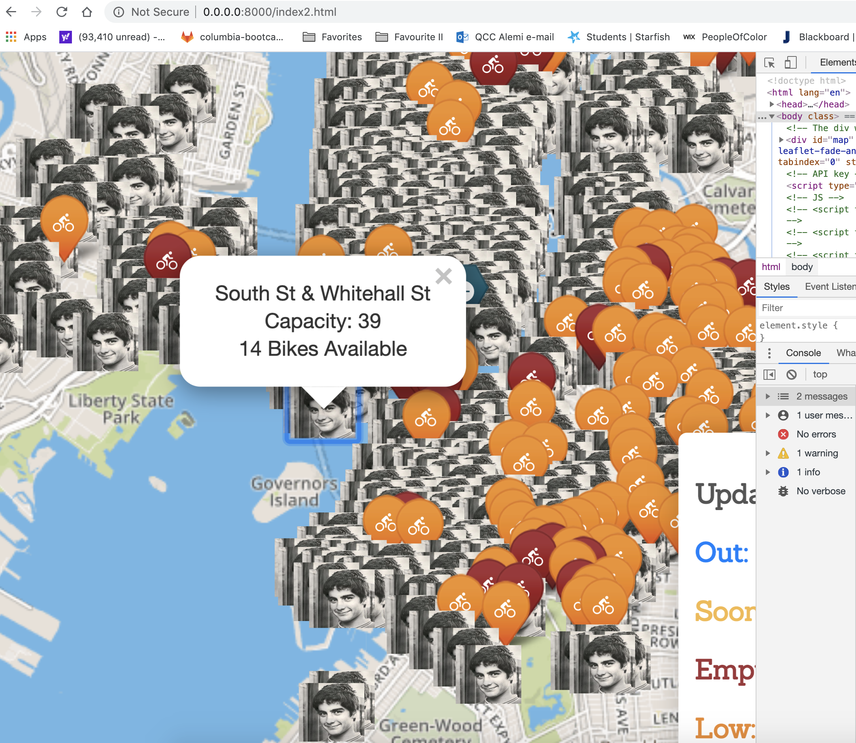

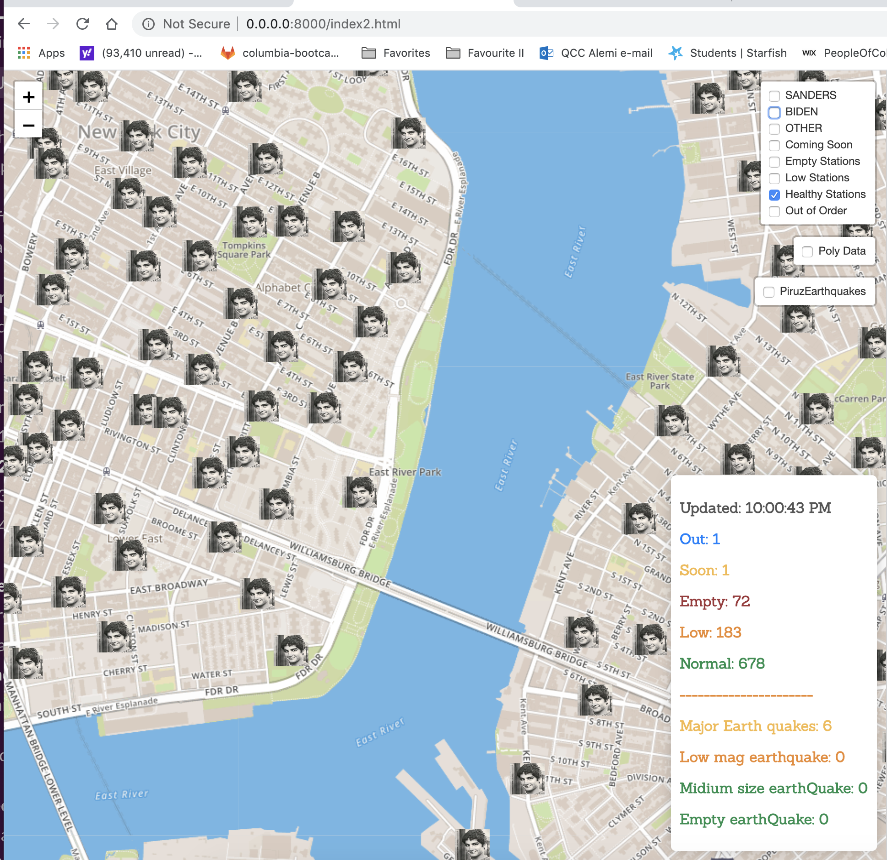

Flask Output:

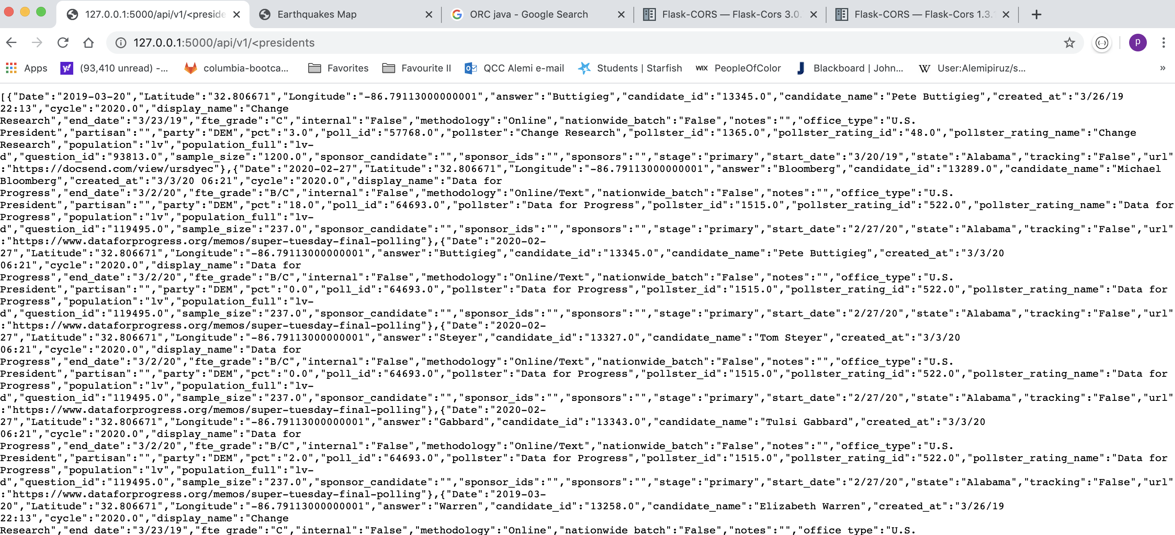

Thank you! & Have a wonderful day.